Client: 172.16.0.8

Server: 64.13.134.52

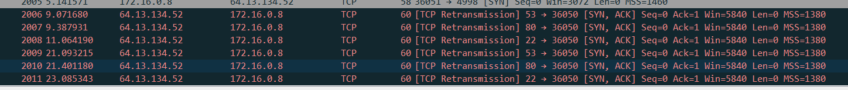

Ports 53(DNS), 80(HTTP), 22(SSH) send back SYN, ACK

-> so they must be open.

syn7.png

syn5.png

syn3.png

syn2.png

Ports 70(Gopher), 113(Ident), 31337(Back Orifice remote administration tool), 25(SMTP) send back RST, ACK

-> so they must be closed

Using nmap:

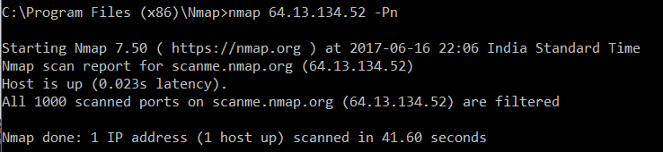

Nmap cannot determine whether the port is open because packet filtering prevents its probes from reaching the port. The filtering could be from a dedicated firewall device, router rules, or host-based firewall software.